**ADM3 Analysis & Assessment | Part 1**

**Section 1: General Data Analysis**

1. Based on the Model Performance Raw, which models showed a positive trend in both revenue and fans over the two-week period (Feb17-23 and Feb24-Mar02)? How would you present this data visually to highlight the trend?

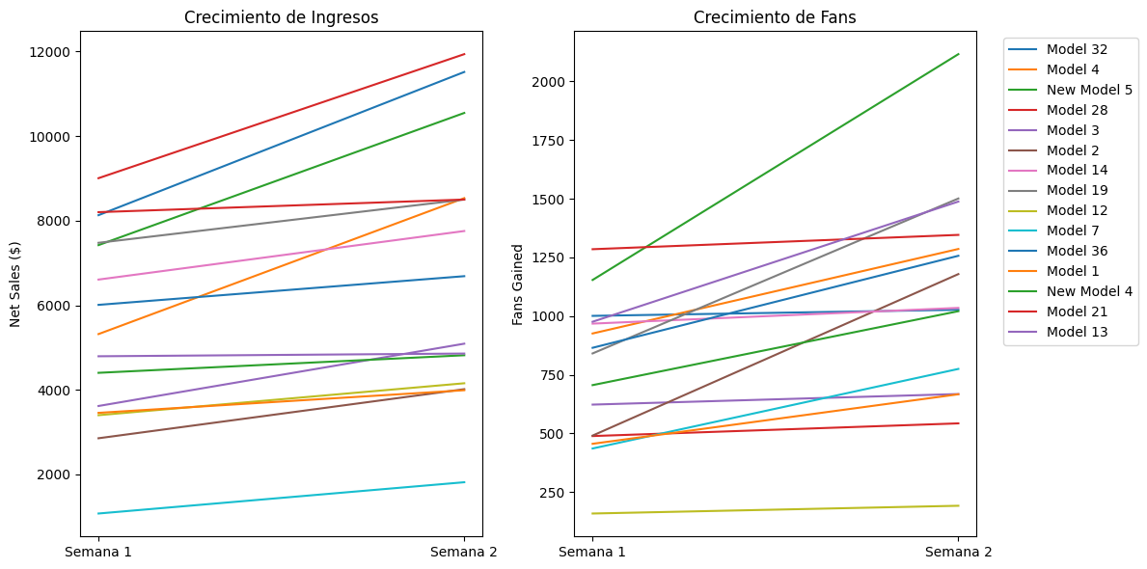

1. Given the information on new models, how would you analyze their performance compared to existing models? What statistical methods would you use?

T-test:  
  
=== Basic Statistics ===

New Models:

Net Sales Fans Gained

count 115.000000 114.000000

mean 1026.365913 134.377193

std 764.510515 188.727335

min 0.000000 0.000000

25% 494.270000 30.000000

50% 820.810000 63.000000

75% 1275.630000 134.500000

max 3525.250000 882.000000

Existing Models:

Net Sales Fans Gained

count 2318.000000 2176.000000

mean 1356.317748 166.765625

std 1307.034369 183.744336

min 0.000000 0.000000

25% 522.467500 52.000000

50% 1003.495000 120.000000

75% 1710.617500 237.250000

max 8437.560000 4965.000000

=== T-Test Results ===

Net Sales - t-stat: -4.33, p-value: 0.0000

Fans Gained - t-stat: -1.79, p-value: 0.0761

Interpretation for Net Sales:

- The difference in Net Sales between new and existing models IS statistically significant (p = 0.0000)

- New models have lower average Net Sales (t = -4.33)

Interpretation for Fans Gained:

- The difference in Fans Gained between new and existing models IS NOT statistically significant (p = 0.0761)

The results indicate that there is no difference in both groups of models for fans gaining, but for Net sales there are a significant difference, so, new models need to be more efficients in order to improve the sales.

1. Assuming the report mentions challenges like managing unresponsive fans and handling pricing objections. What data-driven approach would you use to identify and address these issues?

Challenge 1: Managing Unresponsive Fans

Data-Driven Solutions:

Engagement Segmentation

Calculate response rates (e.g., messages replied to vs. ignored) per fan/model.

- Use clustering (e.g., K-means) to group fans into segments:

        Active: High response rate, frequent interactions

        Passive: Low response rate but occasional engagement

        Inactive: No response despite outreach

# Example: Segment fans by response rate (if response data exists)

#from sklearn.cluster import KMeans

#fan_data = df.groupby('Fan ID').agg({'Response_Rate': 'mean', 'Interaction_Count': 'sum'}).dropna()

#kmeans = KMeans(n_clusters=3).fit(fan_data)

#fan_data['Segment'] = kmeans.labels_

Challenge 2: Handling Pricing Objections

Price Sensitivity Analysis

A) Calculate elasticity: % change in fan conversions vs. % change in pricing tiers.

    Identify "sweet spots" where revenue and fan growth are balanced.

# Example: Elasticity approximation (if tiered pricing exists)

#price_tiers = df.groupby('Price_Tier').agg({'Net Sales': 'sum', 'Fans_Gained': 'sum'})

#price_tiers['Sales_per_Fan'] = price_tiers['Net Sales'] / price_tiers['Fans_Gained']

B) A/B Testing for Pricing: Test small price adjustments (e.g., ±10%) on similar audience segments. Measure impact on conversion rates and revenue.

Dynamic Pricing Models: Use ML (e.g., regression, classification (if data is labeled)) to recommend optimal prices per fan segment:

High-engagement fans: Premium pricing (less price-sensitive).

New fans: Discounted trials to reduce objections.

**Section 2: Boost & Promotional Impact Analysis**

1. In the *Model Perf on BOOST* tab, to process Impact Analysis, removing three boosts from Model 6, Model 7, Model 8, Model 9, and 10 led to a loss of X number of fans and Y in revenue. How would you forecast the long-term impact of removing these boosts?

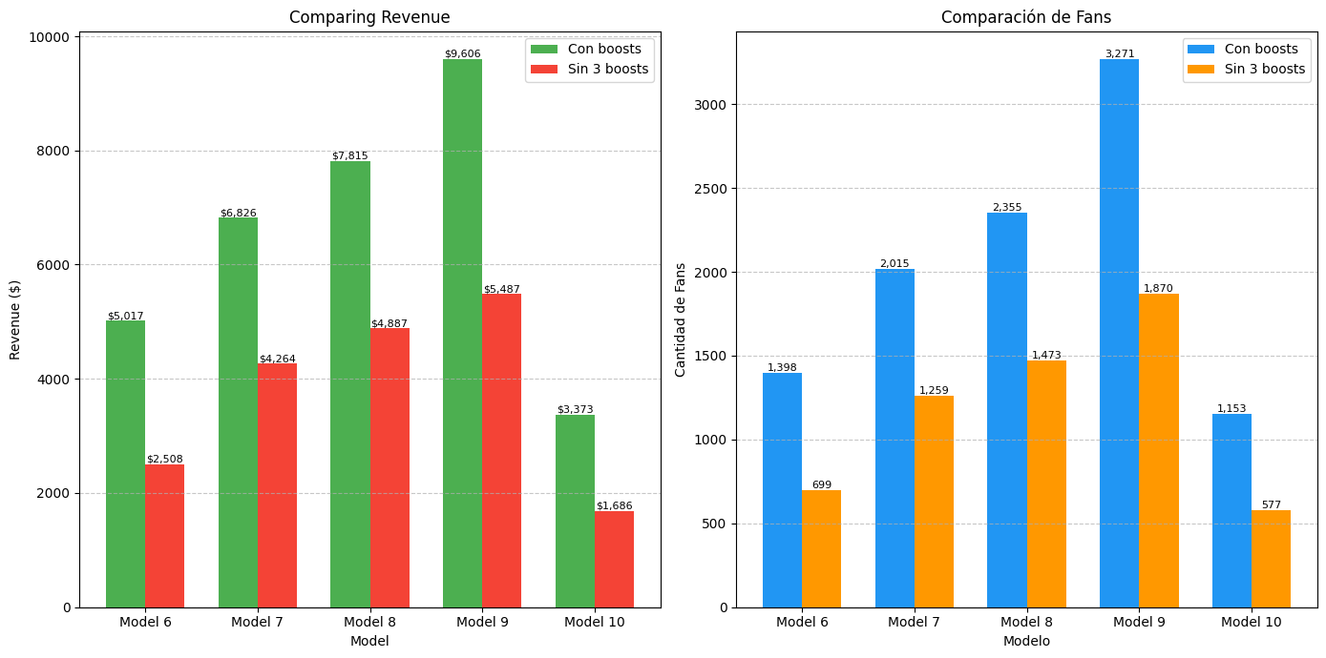

Summary:

Total Revenue (Current): $32,638.59

Revenue without 3 boosts: $18,831.48

Difference: -$13,807.11 (42.3%)

Total Fans (Current): 10,192

Fans without 3 boosts: 5,878

Difference: -4,314 (42.3%)

1. Model 19's boost performance averaged $1.72 per fan, below the $3 target. What factors would you analyze to improve the efficiency of boost campaigns?

Analysis for Model 19 ($1.72 per fan):

- Agency: R (average: $2.93 per fan)

- Total fans: 1325

- Fans per boost: 221

Key factors to analyze:

1. Content quality and type

2. Boost frequency and timing

3. Target audience segmentation

4. Pricing strategy

5. Fan retention

6. Cross-promotion with other models

Top-performing similar models:

MODEL $ per fan AVE SUBS COUNT

Model 20 6.64 410

Model 5 5.21 432

Model 21 4.93 471

Model 22 4.93 365

Model 23 3.80 258

Model 6 3.59 233

Model 24 3.54 382

Model 8 3.32 294

Model 1 3.23 229

Model 25 3.19 304

Recommendations:

1. Optimize timing (best average time: 338 fans/boost)

2. Analyze content from top models: Model 20, Model 5, Model 21

3. Target audience similar to high $/fan models

4. A/B testing with different pricing strategies

1. Using the Promo Raw tab, calculate the cost per acquisition (CPA) for each model. What strategies would you recommend to optimize promo campaigns to lower the CPA while maintaining engagement? Setting the target at $3.00

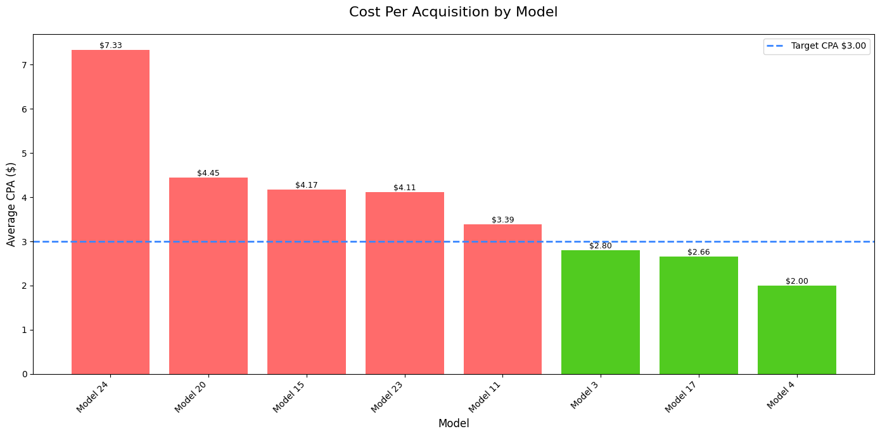

================================================================================

=============== AUTOMATED CAMPAIGN OPTIMIZATION RECOMMENDATIONS ================

================================================================================

XXX HIGH CPA MODELS (NEED OPTIMIZATION):

MODEL: Model 24

• Current CPA: $7.33 (Spent: $1,840, Subs: 251)

• Campaigns run: 7

TOP PERFORMING COMBINATIONS:

• AM 44: CPA $4.69 (Spent: $150, Subs: 32)

• AM 50: CPA $5.56 (Spent: $150, Subs: 27)

• AM 34: CPA $6.15 (Spent: $240, Subs: 39)

WORST PERFORMING COMBINATIONS:

• AM 26: CPA $7.69 (Spent: $300, Subs: 39)

• AM 36: CPA $8.11 (Spent: $300, Subs: 37)

• AM 47: CPA $23.08 (Spent: $300, Subs: 13)

RECOMMENDED ACTIONS:

1. REDUCE spending on AM 47 (CPA $23.08)

2. REALLOCATE $150 from worst combo to best combo (AM 44)

3. TEST 2 new ASSIST/MODEL variations to find better performers

4. If CPA remains high, consider PAUSING this model temporarily

MODEL: Model 20

• Current CPA: $4.45 (Spent: $2,590, Subs: 582)

• Campaigns run: 9

TOP PERFORMING COMBINATIONS:

• AM 28: CPA $1.95 (Spent: $500, Subs: 256)

• AM 39: CPA $2.70 (Spent: $100, Subs: 37)

• AM 34: CPA $3.93 (Spent: $240, Subs: 61)

WORST PERFORMING COMBINATIONS:

• AM 26: CPA $9.09 (Spent: $300, Subs: 33)

• AM 12: CPA $11.76 (Spent: $400, Subs: 34)

• AM 2: CPA $15.38 (Spent: $400, Subs: 26)

RECOMMENDED ACTIONS:

1. REDUCE spending on AM 2 (CPA $15.38)

2. REALLOCATE $200 from worst combo to best combo (AM 28)

3. TEST 2 new ASSIST/MODEL variations to find better performers

4. If CPA remains high, consider PAUSING this model temporarily

MODEL: Model 15

• Current CPA: $4.17 (Spent: $1,350, Subs: 324)

• Campaigns run: 5

TOP PERFORMING COMBINATIONS:

• AM 14: CPA $2.25 (Spent: $200, Subs: 89)

• AM 44: CPA $3.49 (Spent: $150, Subs: 43)

• AM 47: CPA $4.11 (Spent: $300, Subs: 73)

WORST PERFORMING COMBINATIONS:

• AM 47: CPA $4.11 (Spent: $300, Subs: 73)

• AM 31: CPA $5.71 (Spent: $400, Subs: 70)

• AM 37: CPA $6.12 (Spent: $300, Subs: 49)

RECOMMENDED ACTIONS:

1. REDUCE spending on AM 37 (CPA $6.12)

2. REALLOCATE $150 from worst combo to best combo (AM 14)

3. TEST 2 new ASSIST/MODEL variations to find better performers

4. If CPA remains high, consider PAUSING this model temporarily

MODEL: Model 23

• Current CPA: $4.11 (Spent: $900, Subs: 219)

• Campaigns run: 3

TOP PERFORMING COMBINATIONS:

• AM 47: CPA $3.30 (Spent: $300, Subs: 91)

• AM 37: CPA $4.48 (Spent: $300, Subs: 67)

• AM 26: CPA $4.92 (Spent: $300, Subs: 61)

WORST PERFORMING COMBINATIONS:

• AM 47: CPA $3.30 (Spent: $300, Subs: 91)

• AM 37: CPA $4.48 (Spent: $300, Subs: 67)

• AM 26: CPA $4.92 (Spent: $300, Subs: 61)

RECOMMENDED ACTIONS:

1. REDUCE spending on AM 26 (CPA $4.92)

2. REALLOCATE $150 from worst combo to best combo (AM 47)

3. TEST 2 new ASSIST/MODEL variations to find better performers

4. If CPA remains high, consider PAUSING this model temporarily

MODEL: Model 11

• Current CPA: $3.39 (Spent: $875, Subs: 258)

• Campaigns run: 4

TOP PERFORMING COMBINATIONS:

• AM 39: CPA $1.22 (Spent: $100, Subs: 82)

• AM 36: CPA $3.23 (Spent: $300, Subs: 93)

• AM 33: CPA $3.62 (Spent: $275, Subs: 76)

WORST PERFORMING COMBINATIONS:

• AM 36: CPA $3.23 (Spent: $300, Subs: 93)

• AM 33: CPA $3.62 (Spent: $275, Subs: 76)

• AM 21: CPA $28.57 (Spent: $200, Subs: 7)

RECOMMENDED ACTIONS:

1. REDUCE spending on AM 21 (CPA $28.57)

2. REALLOCATE $100 from worst combo to best combo (AM 39)

3. TEST 2 new ASSIST/MODEL variations to find better performers

4. If CPA remains high, consider PAUSING this model temporarily

WELL-PERFORMING MODELS (MAINTAIN/SCALE):

MODEL: Model 3

• Current CPA: $2.80 (Spent: $990, Subs: 353)

BEST OPPORTUNITY TO SCALE:

• AM 34: CPA $1.69 (Spent: $240, Subs: 142)

RECOMMENDED ACTIONS:

1. INCREASE budget for AM 34 by 30-50%

2. MONITOR CPA closely during scaling

3. TEST similar ASSIST/MODEL variations

MODEL: Model 17

• Current CPA: $2.66 (Spent: $700, Subs: 263)

BEST OPPORTUNITY TO SCALE:

• AM 36: CPA $2.17 (Spent: $300, Subs: 138)

RECOMMENDED ACTIONS:

1. INCREASE budget for AM 36 by 30-50%

2. MONITOR CPA closely during scaling

3. TEST similar ASSIST/MODEL variations

MODEL: Model 4

• Current CPA: $2.00 (Spent: $300, Subs: 150)

BEST OPPORTUNITY TO SCALE:

• AM 32: CPA $2.00 (Spent: $300, Subs: 150)

RECOMMENDED ACTIONS:

1. INCREASE budget for AM 32 by 30-50%

2. MONITOR CPA closely during scaling

3. TEST similar ASSIST/MODEL variations

================================================================================

======================= GENERAL OPTIMIZATION STRATEGIES ========================

================================================================================

1. Budget Reallocation:

- Shift 20-30% of budget from worst performers to best performers

2. Testing Framework:

- Run A/B tests on: ASSIST/MODEL combos, ad creatives, targeting

3. Performance Monitoring:

- Set up weekly CPA review meetings for high-spend models

4. Creative Optimization:

- Refresh creatives for models with CPA > $4.00

5. Lookalike Audiences:

- Create lookalike audiences from best converting combos

**Section 3: Performance Metrics & KPIs**

1. In the Swap Data Raw, models like Model 1, Model 2, Model 3 and Model 5 performed well in their swap results (Today is March 17, 2025). What key performance indicators (KPIs) would you use to assess the success of swaps?
2. Assuming that DM Strategy is measured by the average Subs gained and that an average gain of less than 50 subs is considered poor, while 100 or more is ideal. How would you structure a dashboard to track and improve DM performance?
3. What recommendations would you make for improving PPV (pay-per-view) performance, given that there is no hard data per model for success determination?

Unfortunately I didn't understand the table…

**Section 4: Data Visualization & Reporting**

1. If asked to create a monthly performance report dashboard, what key metrics would you include? What visualization techniques would you use to ensure clarity and insightfulness?

I’d treat the dashboard like a story-clear chapters, strong visuals, and a narrative that drives action. Key metrics would include revenue trends, engagement rates, conversion funnels, top-performing channels, and growth KPIs like fan acquisition or retention.

To make it pop visually, I’d mix line graphs (for time-based insights), interactive bar charts (for comparisons), heatmaps (for spotting intensity), and bold KPI tiles for quick wins.

1. The social media raw tab highlights top performers based on different metrics (revenue, clicks, and fan growth). How would you use A/B testing to optimize social media engagement strategies?

A/B testing for Instagram is like trying out two different album covers to see which one gets more people to stop scrolling. Let’s say we notice our carousel posts about "5-minute recipes" are getting good reach, but we want to boost engagement even more.

We’d split our audience randomly, run both for 48 hours, and track which one drives more saves, shares, or recipe clicks. If Version B wins, we’d use that style more often but keep testing, because what works today might not next month.

The goal isn’t just chasing likes; it’s learning why certain content hooks our audience, so we can replicate consistently.

**Section 5: Problem-Solving & Strategy**

1. The reports suggest that some promotional images were rated as low quality, affecting marketing performance. How would you quantify the impact of visual quality on conversion rates?

Visuals speak louder than words and bad ones can mute the message. I’d group campaigns by image quality (based on ratings or predefined criteria) and compare their conversion rates using A/B testing or regression analysis.  
Then, I’d visualize the drop-off or lift in performance linked to image quality.

1. Model 19’s page engagement is low, with response rates of as few as four replies per hour. What actionable steps would you suggest to increase fan interaction based on data trends?

If interactions are low, we should first apply a booster or take image improvement actions or strategies in the posts. The content is probably not the most striking, so we should definitely test strategies in the posts to generate interactions by replicating strategies from top models. Some strategies could be polls, asking open questions, and so on.

1. Fans have been requesting longer solo videos, but the content vault is limited to shorter clips. How would you analyze the demand for different content types and recommend a content strategy?

When fans talk, data listens. I’d analyze watch time, repeat views, and comment sentiment across current clips to spot demand signals, even topic analysis. Are viewers replaying the same short clips? Asking for more in the comments? That’s an answer. The key is recognize VOCs, maybe other formats could be more profitable.